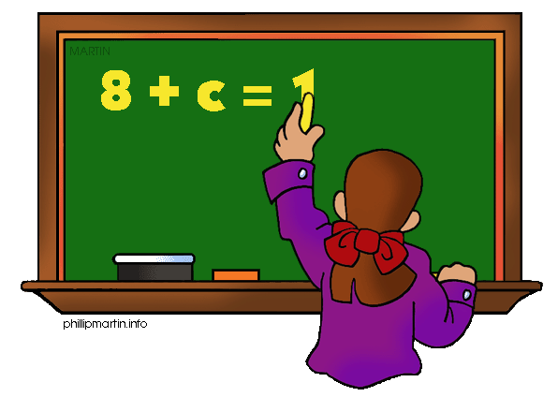
Name___________________________ Date_________________ Pd____
Determine if each statement/item applies to Expressions, Equations, and/or Inequalities. Some statements may apply to more than one. Put a check in the correct column(s).
 | Expression | Equation | Inequality
- Contains an equal sign
- Cannot be ‘solved’
- $3x+4$
- $10<21$
- Has multiple solutions
- $12=3+x$
- Can contain numbers
- A mathematical sentence
- $7w$
- $4=12÷3$
- Can contain variables
- Can be compared to a scale
- A mathematical phrase
- $x≥9$
- $x+8<37-2$
- Like a balanced scale
- $7+1$
- $7+1=8$
- $7+1≥8$
- Can contain operation symbols (+,-,x,$÷$)
- $\frac{3}{4}+7\left(2\right)-12+3^{0}$
- $5-x=12$
- $5-x$
- Usually has one solution
- Like an unbalanced scale

